Haoyuan Qin (001048178)

**Program Structures & Algorithms**

**Fall 2021**

**Assignment No. 3**

* **Task (List down the tasks performed in the Assignment)**
* **Relationship Conclusion: (For ex : z = a * b)**

N : objects M: pairs

N = m + 1

* **Evidence to support the conclusion:**

Step 3 relationship between N & M

If we have N objects if we want to connect them the minimum number is N-1.

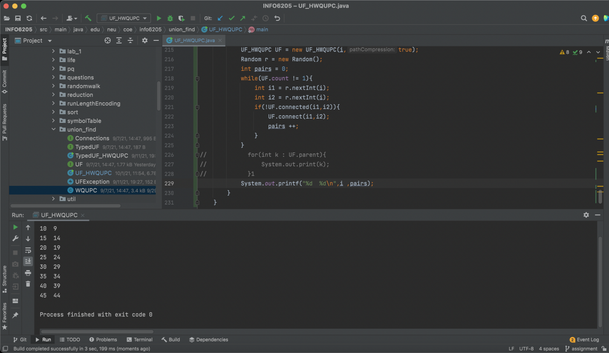**Output (Snapshot of Code output in the terminal)**

1. **Graphical Representation(Observations from experiments should be tabulated and analyzed by plotting graphs(usually in excel) to arrive on the ßrelationship conclusion)**

Step2 all the objects connect to one root

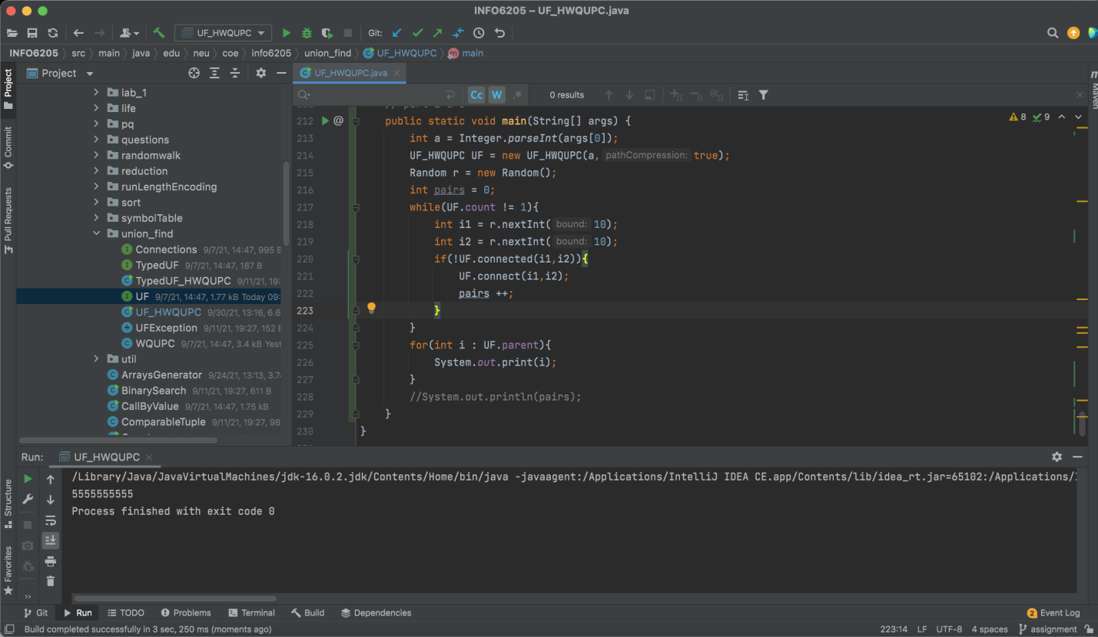

* **Unit tests result:(Snapshot of successful unit test run)**

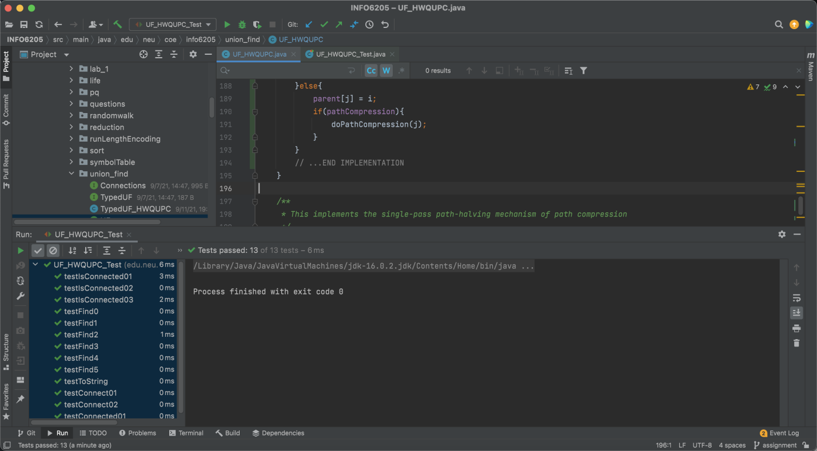

3.Your ****code**** (*RandomWalk.java* plus anything else that you changed or created);

<https://github.com/Jim-Qin/INFO_6205_Assignments.git>